SpringMVC Framework

- SpringMVC framework is an open source web application framework which is a part of Spring framework.
- SpringMVC framework is one of the efficient and high performance open source implementation of Model-View-Controller (MVC-2).
- SpringMVC framework provides utility classes to handle most common tasks in the Web Application development.
- As an enterprise Java developer, you’ve likely developed a web-based application or two.
- For many Java developers, web-based applications are their primary focus. If you do have this type of experience, you’re well aware of the challenges that come with these systems.
- Specifically, state management, workflow, and validation are all important features that need to be addressed. None of these is made any easier given the HTTP protocol’s stateless nature.
- Spring’s web framework is designed to help you address these concerns. Based on the Model-View-Controller (MVC) pattern, Spring MVC helps you build web- based applications that are as flexible and as loosely coupled as the Spring Frame- work itself.
- In terms of web application development, Spring provides comprehensive and intensive support.
- The Spring MVC module provides a solid infrastructure and Model View Controller (MVC) framework for web application development.
- When using Spring MVC, you can use various view technologies (for example, JSP, Velocity, and so on). In addition, Spring MVC integrates with many common web frameworks and toolkits (for example, Struts, Adobe Flex, GWT, and so on).

Model View Controller
- MVC is a commonly used pattern in implementing the presentation layer of an application.
- The main principle of the MVC pattern is to define an architecture with clear responsibilities for different components.
- As its name implies, there are three participants within the MVC pattern:

• Model: A model represents the business data as well as the “state” of the
application within the context of the user. For example, in an e-commerce
web site, the model will include the user profile information, shopping cart
data, and order data if users purchase goods on the site.
• View: This presents the data to the user in the desired format, supports interaction
with users, and supports client-side validation, i18n, styles, and so on.
• Controller: The controller handles requests for actions performed by users in the
frontend, interacting with the service layer, updating the model, and directing
users to the appropriate view based on the result of execution.
SpringMVC Architecture

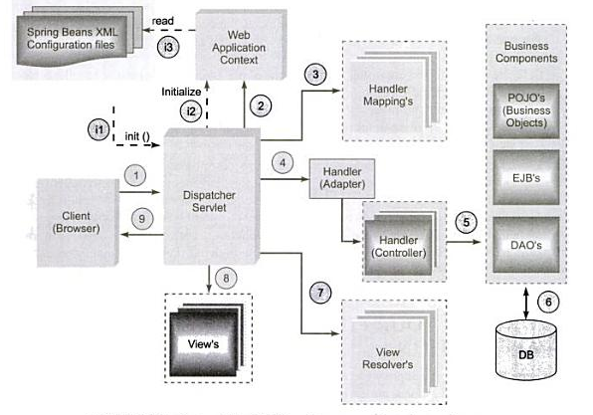
Life Cycle of a Request in SpringMVC

- Below figure shows the life cycle of a request from start to finish:

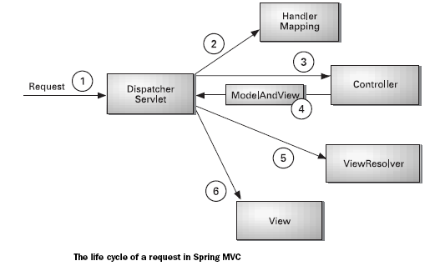

- The process starts when a client (typically a web browser) sends a request (1).
- In SpringMVC framework, the request will be first handled by DispatcherServlet. The DispatcherServlet acts as a front controller in SpringMVC framework.

Note: A Front Controller is a common web application pattern where a single servlet delegates responsibility for a request to other components of an application to perform the actual processing.

- The DispatchServlet uses HandlerMappings (2) to find the Controller to delegate the request. A HandlerMapping typically maps URL patterns to Controller objects.
- The Controller (3) in SpringMVC framework is responsible for handling the requests. The developer has to provide request processing logic in Controller.
- The Controller returns a ModelAndView object (4) to the DispatcherServlet. The ModelAndView can either contain a View object or a logical name of a view object.
- If the ModelAndView object contains the logical name of a view, then DispatcherServlet uses a ViewResolver (5) to find the view object that will render the response.
- Finally, the DispatcherServlet dispatches the request to the view object (6) indicated by the ModelAndView object. The View object is responsible for rendering a response back to the client.

Configuring DispatcherServlet
- The first stop in the request’s travels is at Spring’s DispatcherServlet.
- Like most Java-based web frameworks, Spring MVC funnels requests through a single front con-troller servlet.
- A front controller is a common web application pattern where a single servlet delegates responsibility for a request to other components of an application to perform actual processing.
- In the case of Spring MVC, DispatcherServlet is the front controller.
- The DispatcherServlet’s job is to send the request on to a Spring MVC controller.
- A controller is a Spring component that processes the request. But a typical application may have several controllers and DispatcherServlet needs some help deciding which controller to send the request to.
- So the DispatcherServlet consults one or more handler mappings to figure out where the request’s next stop will be. The handler mapping will pay particular attention to the URL carried by the request when making its decision.

- Configure DispatcherServlet in web.xml as shown below:
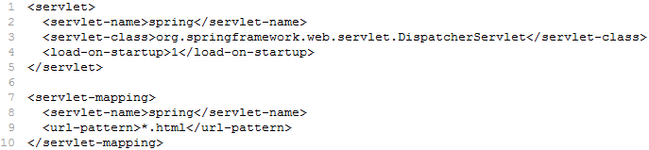
- The DispatcherServlet will load the Spring application context from an XML file whose name is based on the name of the servlet. In this case, the DispatcherServlet will try to load the application context from a file named “spring-servlet.xml”.
- The developer has to create “spring-servlet.xml” file in WEB-INF folder.
- The DispatcherServlet will handle all request URLs that end with “.html” (based on url-pattern configuration above).
Breaking up the application context

- The DispatcherServlet will load the Spring application context from a single XML file whose name is based on its <servlet-name>.
- We can also split our application context into multiple XML files as shown below:
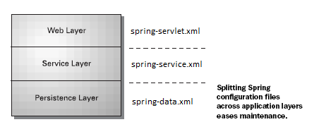
- To load all the configuration files, developer should configure a ContextLoaderListener in web.xml as shown below:
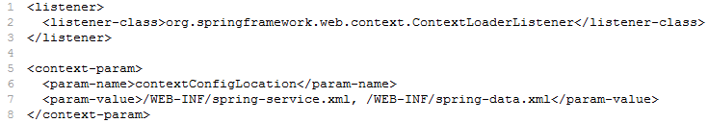
Sample Spring MVC Application

- The following list of steps defines the minimum that you must do to build the home page in SpringMVC application:
- Write the controller class that performs the request processing logic.
- Configure the controller in DispatcherServlet’s context configuration file (training-servlet.xml).
- Configure a view resolver to tie (associate) the controller to the JSP.
- Write the JSP that will render the home page to the user.

Building the Controller

- In SpringMVC, a Controller is a class that is responsible for handling a request and performing some processing on it.
- The handleRequest() method returns a ModelAndView object that holds both view information and model data that will be used when rendering the output.
- The signature of the handleRequest() is similar to the signature of Servlet’s service() method.

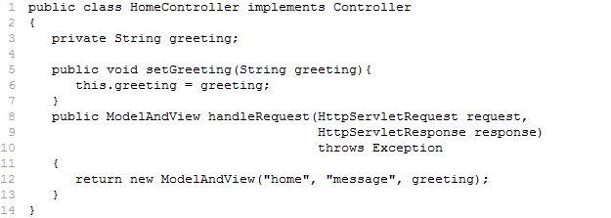

Configuring the Controller

- Configure the HomeController in DispatcherServlet’s context configuration file (i.e. spring-servlet.xml) as shown below:
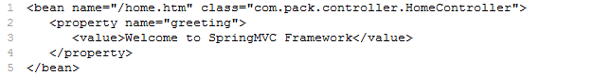

- The “name” attribute is serving double duty i.e., name of the bean and a URL pattern for requests that should be handled by this controller.
- When a request comes to DispatcherServlet with a URL that ends with “/home.htm”, then DispatcherServlet will dispatch the request to HomeController for handling.

Note: The default handler mapping used by DispatcherServlet is BeanNameUrlHandlerMapping, which uses the bean name as the URL pattern.

Declaring a View Resolver:
- A ViewResolver is responsible to take the view name from ModelAndView and map it to a view.
- Developer has to configure ViewResolver in Spring configuration XML file as shown below:
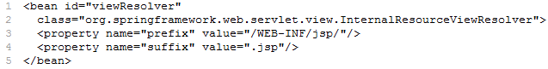

- The InternalResourceViewResolver have two properties:
- prefix
- suffix
- The InternalResourceViewResolver will add the prefix and suffix values to view name to find the view.
- In case of HomeController, it returns a view name “home” in the ModelAndView, InternalResourceViewResolver will find the view at /WEB-INF/jsp/home.jsp

Creating the JSP

- Create “home.jsp” file in /WEB-INF/jsp folder as shown below:
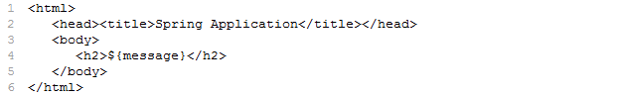

Note: Ensure the name this JSP file is “home.jsp” and place it in /WEB-INF/jsp folder within our web application, that’s where InternalResourceViewResolver will try to find it.

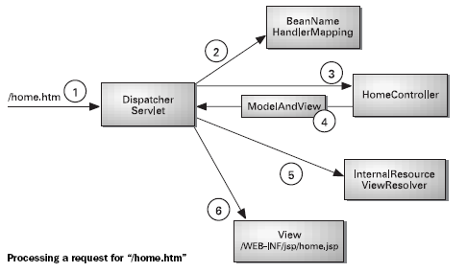

Recap

- DispatcherServlet receives a request whose URL pattern is “/home.html”.
- DispatcherServlet consults BeanNameUrlHandlerMapping to find a controller whose bean name is “/home.html”, finding the HomeController bean.
- DispatcherServlet dispatches the request to HomeController for processing.
- HomeController returns a ModelAndView object with a logical view name as “home”.
- DispatcherServlet consults its view resolver (configured as InternalResourceViewResolver) to find a view whose logical name is “home”. The InternalResourceViewResolver returns the path as /WEB-INF/jsp/home.jsp.
- DispatcherServlet forwards the request to the JSP at /WEB-INF/jsp/home.jsp to render the home page to the user.
ModelAndView

- The ModelAndView class plays important role in SpringMVC. The Controller will return a ModelAndView after the execution. A ModelAndView object, as its name implies, encapsulates the view and model data that is to be displayed by the view.

- In the case of HomeController, the ModelAndView object is constructed as follows:
ModelAndView mav = new ModelAndView ("home", "message", greeting);
- The first parameter of ModelAndView constructor is a logical name of a view that will be used to display the output. Here the logical name of the view is ‘home’. A view resolver will use this name to find the View.
- The next two parameters represent the model object that will be passed to the view. These two parameters act as a name-value pair. The second parameter is the name of the model object and the third parameter is actual model object.

Annotation in SpringMVC

- Spring 2.5 introduced an annotation based programming model for MVC controller that uses annotations such as @Controller, @RequestMapping, @ModelAttribute etc.

@Controller

- The @Controller annotation indicates that a particular class serves the role of a controller. The Spring container automatically detects and registers the classes annotated with @Controller as Spring components.
- The “value” element of @Controller annotation takes name of the component. This is optional.
- Confgure <context: component-scan> in Spring configuration XML file.

@RequestMapping

- The @RequestMapping annotation is used to map request URLs to a particular handler method in controller or controller class itself.
- We can use @RequestMapping on top of a handle method to map a request URL to this method.
- We can use @RequestMapping on top of a controller class to map a request URL to controller and provide additional method-level annotations narrowing the primary mapping for a specific HTTP method [GET/POST] or specific HTTP request parameters.
- The optional elements of @RequestMapping are:
Element | Description
name | Assign a name to this mapping
value | The primary mapping expressed by this annotation
method | The HTTP request methods to map to, narrowing the primary mapping: GET, POST, HEAD, OPTIONS, PUT, DELETE, TRACE
params | The parameters of the mapped request, narrowing the primary mapping
consumes | The consumable media types of the mapped request, narrowing the primary mapping
produces | The producible media types of the mapped request, narrowing the primary mapping

Example to demonstrate @Controller and @RequestMapping Annotations

Solution [HomeController.java]
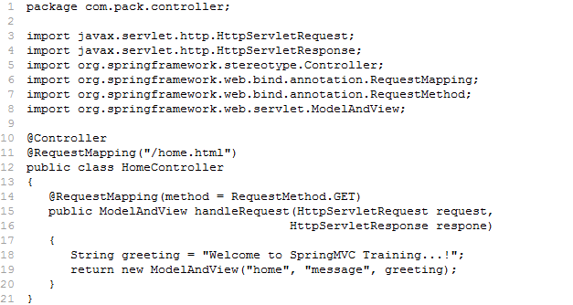

Solution [home.jsp]
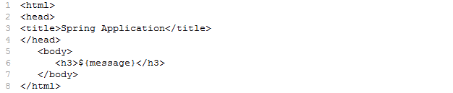

Solution [dispatcher-servlet.xml]
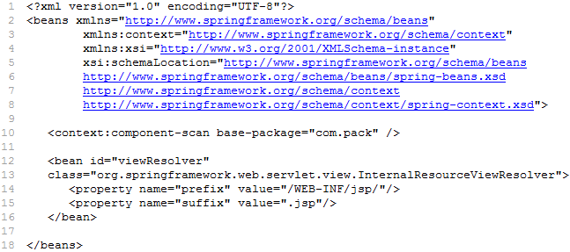

Solution [web.xml]
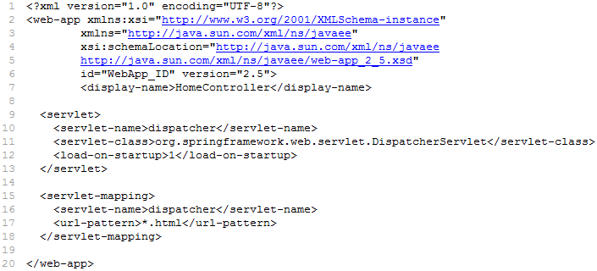

Project Structure in Eclipse:

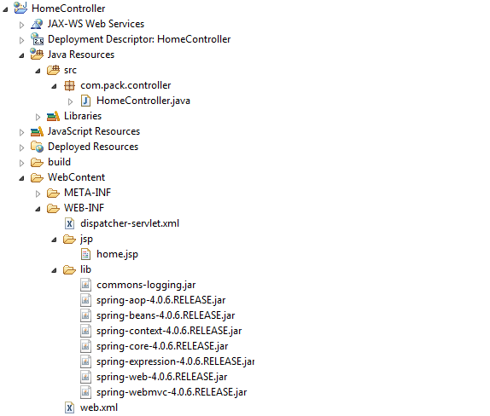

Output:

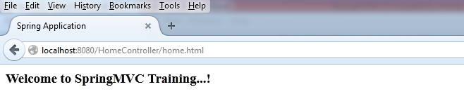

Command class or Form-Backing object

- In Spring Web MVC you can use a simple Java bean as a command or form-backing object; you do not need to implement a framework specific interface or base class.
- A form-backing object is used to hold the form data submitted by user.

@ModelAttribute

- The @ModelAttribute annotation is used to bind the request parameters or form fields to a model object (command class or POJO).
- The @ModeAttribute annotation can be used at method arguments or before the method declaration.
- The “value” element of @ModelAttribute annotation takes the name of the model attribute to bind to. This is optional.

Validating Input Form Data in Spring

- Validating the input form data is most common requirement in application development. Spring Web MVC framework provides a built-in support for the input form data validation. The following two steps are involved in validation:

- Write a validator class
- The developer has to create a validator class that should be a subtype of org.springframework.validation.Validator interface. The Validator interface declares two methods supports() and validate().
public boolean supports(Class c)
- The supports() method takes an argument of java.lang.Class type. This is responsible to decide either this validator is designed to validate the given class type of object or not.
public void validate(Object target, Errors errors)
- The validate() method is responsible for validating the fields of the command class that this validator supports. To validate fields we can use ValidationUtils convenient utility methods.
- Associate the validator to the Controller
- Inject the validator class to controller either using setter/constructor through XML configuration or @Autowired annotation.
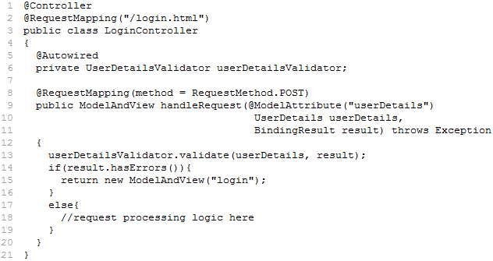
ValidationUtils

- ValidationUtils is a utility class provided by Spring framework to validate and reject empty fields. The mostly used methods of ValidationUtils class are:
Modifier and Type | Method and Description
static void | invokeValidator(Validator validator, Object object, Errors errors)  - Used to validate complex object i.e., command class conatins another command class.
static void | rejectIfEmpty(Errors error, String field, String errorCode, Object[] errorArgs, String defaultMessage)  - Reject the given field if the value is empty.
static void | rejectIfEmptyOrWhitespace(Errors error, String field, String errorCode, Object[] errorArgs, String defaultMessage)  - Reject the given field if the value is empty or contains whitespace.

Errors

- The Spring framework uses Errors interface to store and exposes the data-binding and validation errors of a command class.
- The mostly used methods of Errors interface are:
Modifier and Type | Method and Description
static void | reject(String errorCode, Object[] errorArgs, String defaultMessage)  - Register a global error for the entire target object, using the given error description.
static void | rejectValue(String field, String errorCode, Object[] errorArgs, String defaultMessage)  - Register a field error for the specified field of the current object (respecting the current nested path, if any), using the given error description.

BindingResult

- BindingResult is sub interface of Errors interface. This interface is used to hold validation errors rejected by validate() method of Validator interface.
- This is useful to decide navigation in controller.
- One of the implementation classes of BindingResult interface is BindException.
Spring Form Tag Library

- Spring provides a set of data binding form tags for handling form data when using JSP and Spring Web MVC.
- Each tag has set of attributes which corresponds to HTML tag attributes.
- The tag library descriptor (TLD) is included in the spring-webmvc.jar. The library descriptor is called springform.tld.
- To use the tags from this library, add the following directive to the top of your JSP page:
<%@ taglib prefix="form" uri="http://www.springframework.org/tags/form"%>
Where form is the tag name prefix you want to use for the tags from this library.

The <form> tag

- The <form> tag renders a HTML form and exposes the command object to its child tags.
- All the other tags in this library are nested tags of the <form> tag.
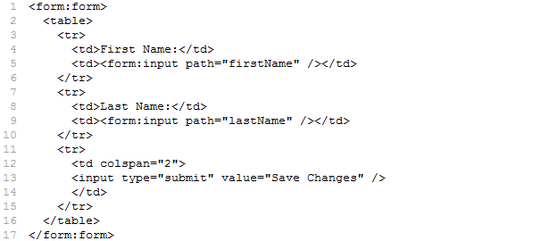

The input tag

- The <input> tag renders a HTML input tag of type text.

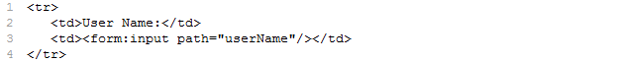
The checkbox tag

- The <checkbox> tag renders a HTML input tag of type checkbox.

The radiobutton tag

- The <radiobutton> tag renders a HTML input tag of type radio.

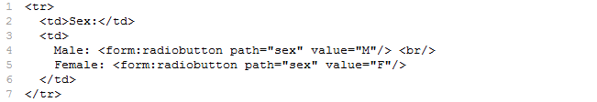

The password tag

- The <password> tag renders a HTML input tag of type password.

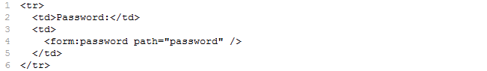

The select tag

- The <select> tag renders a HTML select element. It supports nested option tag.

The option tag

- The <option> tag renders a HTML option.

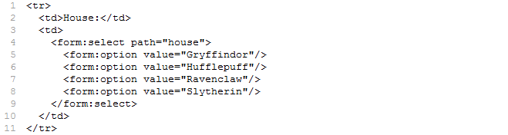

The textarea tag

- The <textarea> tag renders a HTML of type textarea.

The hidden tag

- The <hidden> tag renders a HTML input tag of type hidden bound value.

The errors tag

- The <errors> tag renders validation errors of fields in a HTML form. It provides access to the validation errors created in controller or validator.
- path="*" - displays all errors
- path="lastName" - displays all errors associated with the lastName field

Example to demonstrate Spring Validation & Tag Library

Solution [index.jsp]
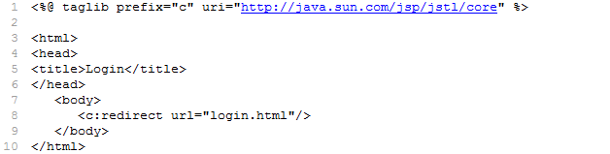

Solution [login.jsp]
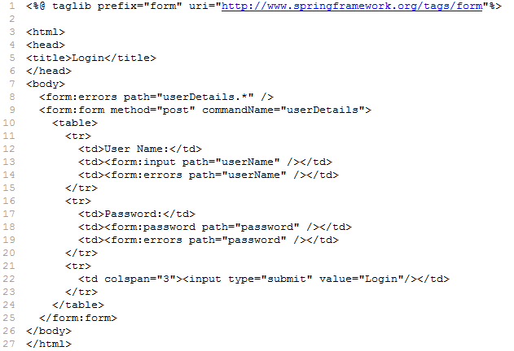

Solution [LoginController.java]
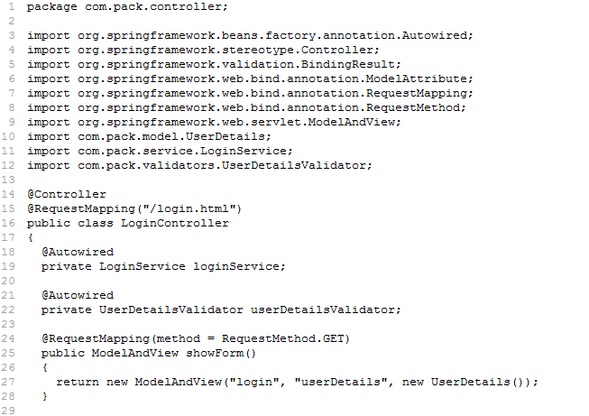
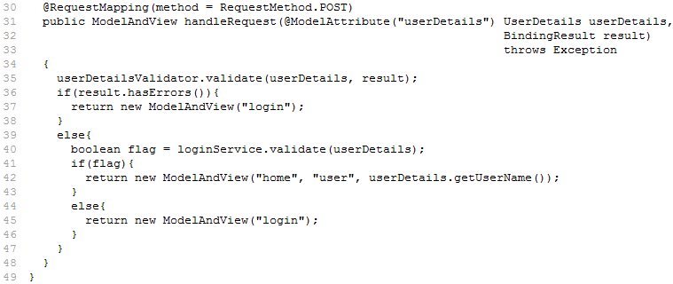

Solution [UserDetailsValidator.java]
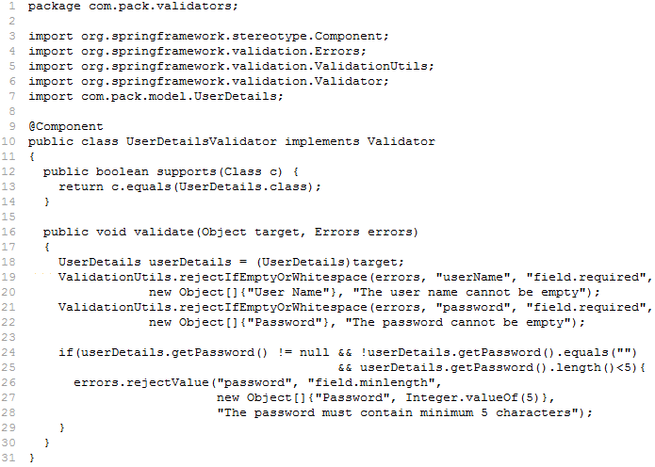

Solution [LoginService.java]
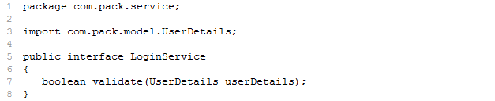

Solution [LoginServiceImpl.java]
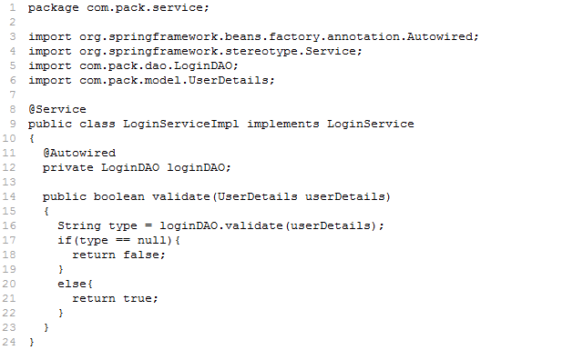

Solution [UserDetails.java]
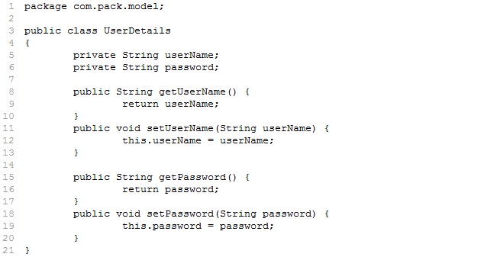

Solution [LoginDAO.java]
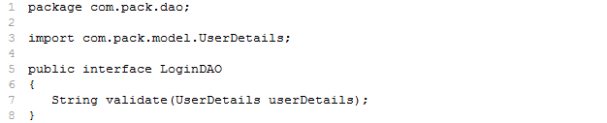

Solution [LoginDAOImpl.java]
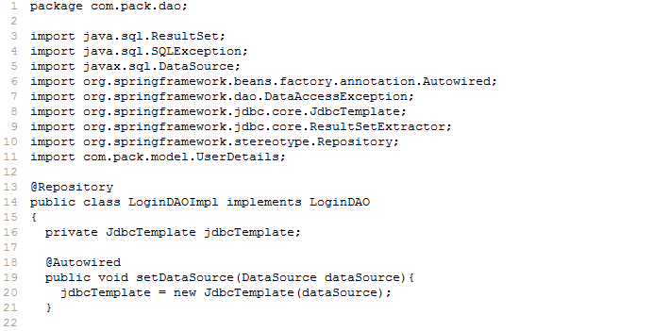
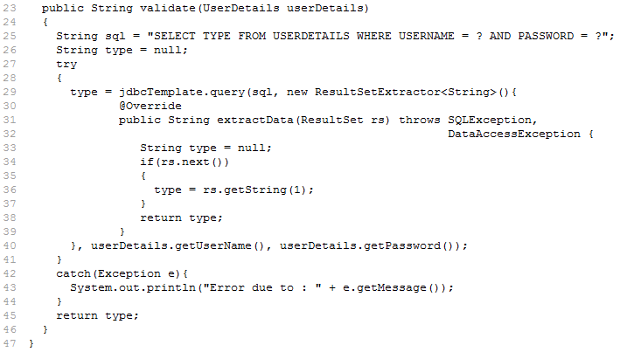

Solution [home.jsp]
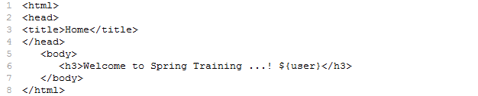

Solution [message.properties]

Solution [dispatcher-servlet.xml]
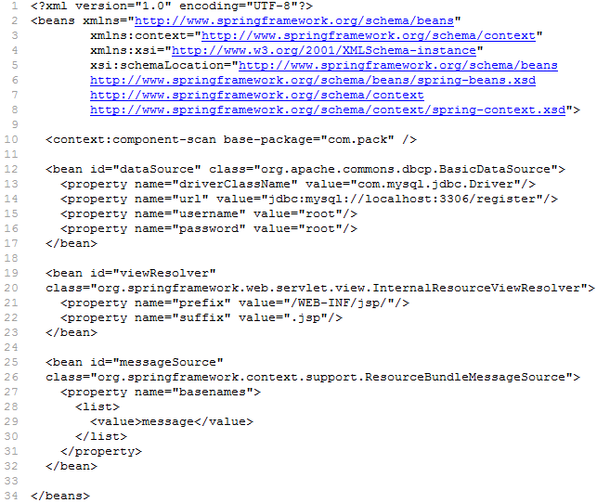

Solution [web.xml]
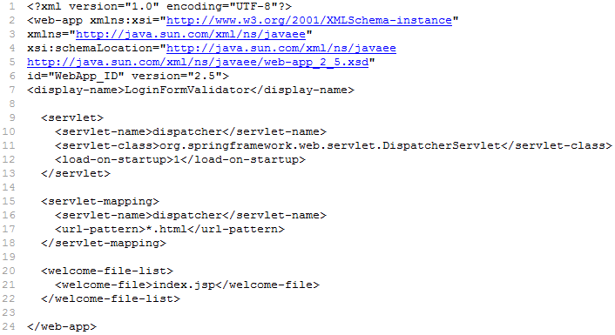

Project Structure in Eclipse:
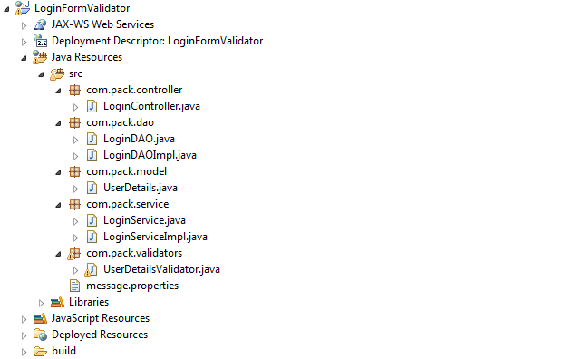
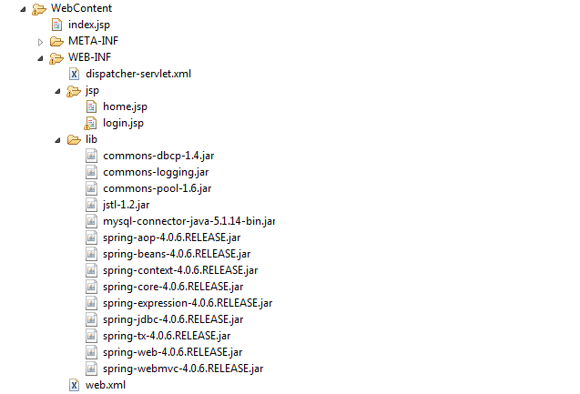

Output:

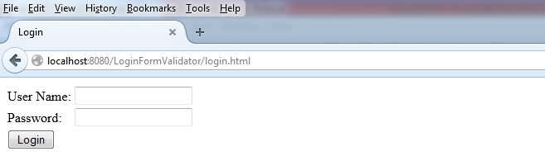

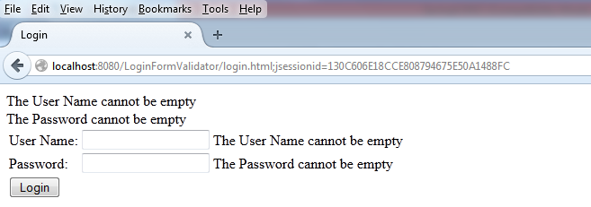

JavaBeans Validation

- JavaBeans Validation (Bean Validation) is a new validation model available as part of Java EE 6 platform.
- The Bean Validation model is supported by constraints in the form of annotations placed on a field, method, or class of a JavaBeans.
- The Constraints can be built-in or user defined. The User-defined constraints are called custom constraints.
- Several built-in constraints are available in the javax.validation.constraints package. The below table lists all the built-in constraints:

Constraint | Description | Example
@AssertFalse | The value of the field or property must be false. | @AssertFalse  boolean flag;
@AssertTrue | The value of the field or property must be true. | @AssertTrue  boolean flag;
@DecimalMax | The value of the field or property must be a decimal value lower than or equal to the number in the value element. | @DecimalMax("30.00")  BigDecimal discount;
@DecimalMin | The value of the field or property must be a decimal value greater than or equal to the number in the value element. | @DecimalMin("5.00")  BigDecimal discount;
@Digits | The value of the field or property must be a number within a specified range. The integer element specifies the maximum integral digits for the number, and the fraction element specifies the maximum fractional digits for the number. | @Digits(integer=6, fraction=2)  BigDecimal price;
@Future | The value of the field or property must be a date in the future. | @Future  Date eventDate;
@Max | The value of the field or property must be an integer value lower than or equal to the number in the value element. | @Max(10)  int quantity;
@Min | The value of the field or property must be an integer value greater than or equal to the number in the value element. | @Min(5)  int quantity;
@NotNull | The value of the field or property must not be null. | @NotNull  String userName;
@Null | The value of the field or property must be null. | @Null  String unusedString;
@Past | The value of the field or property must be a date in the past. | @Past  Date birthday;
@Pattern | The value of the field or property must match the regular expression defined in the regexp element. | @Pattern(regexp="\\(\\d{3}\\)\\d{3}-\\d{4}")  String phoneNumber;
@Size | The size of the field or property is evaluated and must match the specified boundaries. If the field or property is a String, the size of the string is evaluated. If the field or property is a Collection, the size of the Collection is evaluated. If the field or property is a Map, the size of the Map is evaluated. If the field or property is an array, the size of the array is evaluated. Use one of the optional max or min elements to specify the boundaries. | @Size(min=2, max=240)  String briefMessage;
Following are the extra validations provided by Hibernate framework:
Constraint | Description | Example
@NotEmpty | The value of the field or property must not be empty or null. | @NotEmpty  String userName;
@Email | The value of the field or property must be a valid email. | @Email  String email;
@Valid | Perform validation recursively on the associated object. | @Valid  Address address;
Note: Hibernate provides implementation for Beans Validation API
Spring support - Bean Validations
- Spring Framework 4.0 supports Bean Validation 1.0 (JSR-303) and Bean Validation 1.1 (JSR-349). To support bean validations, configure <mvc:annotation-driven/> in Spring configuration XML file.
Tiles Framework

- Tiles is a framework for page composition that allows us to divide the page into parts i.e., partial pages, which can be assembled into a complete page at runtime.
- The Tiles framework provides a standard and simple approach to separate the layout management from the common presentation components.
- The Tiles framework reduces the duplication of frequent page elements (like menu, header, footer etc.,) even avoiding the include statements.

Tiles Tag Library
- The Tiles framework provides tag library. To use the Tiles tag library include “taglib” directive element in JSP as ahown below:
<%@ taglib uri="http://tiles.apache.org/tags-tiles" prefix="tiles"%>

The <tiles:insertAttribute> tag
- The <tiles:insertAttribute> tag inserts the value of an attribute into the page.

Using Tiles Framework in SpringMVC

- Using the Tiles framework involves the following steps:
- Create tiles layout
- Create Tiles i.e., partial pages
- Create tiles definitions
- Register TilesConfigurer class

Creating Tiles Layout
- Tiles framework includes JSP tag library that allows us to create a JSP page as a tiles layout page.
- The following snippet shows a simple layout JSP page:

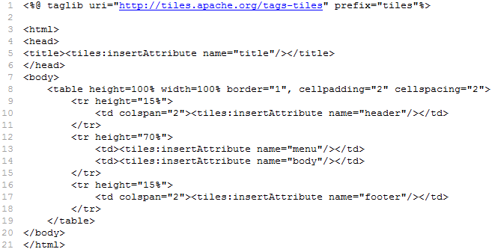

- The <tiles:insertAttribute> element allows us to define a named placeholder for the partial content that will be included into the template to prepare a complete page at runtime.
- These partial contents can be implemented into a separate JSP or HTML pages.

Creating Tiles (i.e., Partial Pages)
- These pages contain the content that has to fill the named placeholders in the layout page.
- These pages are created same way that we would have created the partial JSP pages when we were using the <jsp:include> to separate the common page elements into a JSP and composing them to a complete page.

Creating Tiles Definitions – tiles.xml
- We need to write the tiles definitions and their attributes in the XML document i.e., tiles.xml
- This XML file is loaded at the time of start-up of the application.
- The following snippet shows a sample tiles XML configuration file:

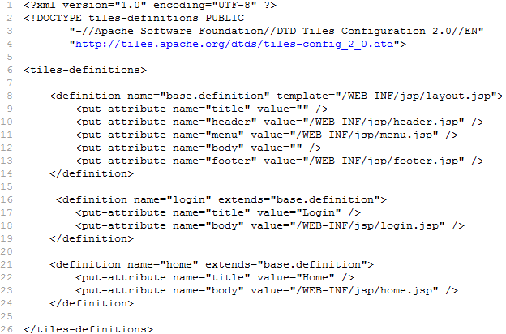

Register TilesConfigurer class
- Once we have designed the layout, the partial content pages and the definitions using the tiles xml configuration file, we need to configure the TilesConfigurer class in Spring XML file as shown below:
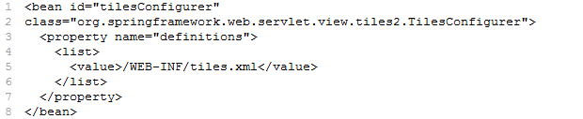

Spring Security:
- Spring Security is a framework that focuses on providing both authentication and authorization to Java applications.
- “Authentication” is the process of establishing a principal is who they claim to be (a “principal” generally means a user, device or some other system which can perform an action in your application).
- “Authorization” refers to the process of deciding whether a principal is allowed to perform an action within your application. To arrive at the point where an authorization decision is needed, the identity of the principal has already been established by the authentication process. These concepts are common, and not at all specific to Spring Security.
- "Authorization" is the assurance that the user is allowed to access only those resources that he is authorized to use.
- For example, in a corporate application, there are some parts of an application where only admin have access and to some parts all the employees have access. These access rules are determined by the access rights given to each user of the system.
- Acegi is the most used web project security tools in respect of Java web development. Acegi is a security framework for authentication, authorization and role based authorization of the users. Spring Security is an implementation of Acegi referral API.
- Spring Security Framework provides a lot of facilities to take care of the java web enterprise security management. Its really great security framework that work with Spring IoC or DI to inject the dependencies and securing the java web application.
- A sample program flow is like the following.
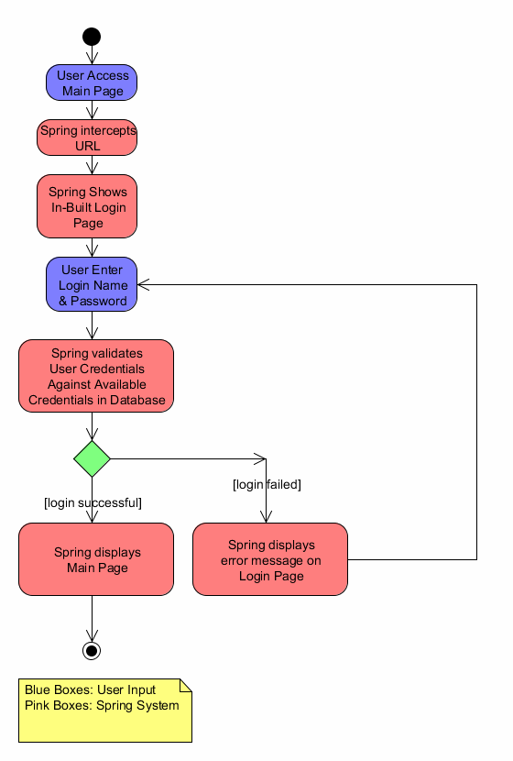

Security configuration:
- web.xml
In order to enable spring security for your web application, you have to add below filter declaration in your web.xml.
- <filter>
- <filter-name>springSecurityFilterChain</filter-name>
- <filter-class> org.springframework.web.filter.DelegatingFilterProxy</filter-class>
- </filter>

- <filter-mapping>
- <filter-name>springSecurityFilterChain</filter-name>
- <url-pattern>/*</url-pattern>
- </filter-mapping>
DelegatingFilterProxy is a Spring Framework class which delegates to a filter implementation which is defined as a Spring bean in your application context. In this case, the bean is named "springSecurityFilterChain", which is an internal infrastructure bean created by the namespace to handle web security. Note that you should not use this bean name yourself. Once you've added this to your web.xml, you're ready to start editing your application context file.
- A Minimal <http> Configuration-
<http auto-config="true"><intercept-url pattern="/**" access="ROLE_USER" /></http>
Which says that we want all URLs within our application to be secured, requiring the role ROLE_USER to access them. The <http> element is the parent for all web-related namespace functionality. The <intercept-url> element defines a pattern which is matched against the URLs of incoming requests using an ant path style syntax. The access attribute defines the access requirements for requests matching the given pattern. With the default configuration, this is typically a comma-separated list of roles, one of which a user must have to be allowed to make the request.
The above configuration declares that all the urls in the application will be intercepted for the security checks and the urls can only be accessed by the user with role ROLE-USER. The attribute "auto-config=true" defines three elements <form-login/>, <http-basic/> and <logout>.The default configuration always chooses http-basic authentication model.

Authentication Model:
Here we decide which authentication model you will use for your web application. Option could be any of the above(LDAP, Open ID..). Once decided same could be configured via “<authentication-manager></authentication-manager>” tag.
- <authentication-manager>
- <authentication-provider>
- <user-service>
- <user authorities="ROLE_USER, ROLE_ADMIN" name="sekhar" password="sekharpassword"/>
- <user authorities="ROLE_USER" name="sweety" password="sweetypassword"/>
- </user-service>
- </authentication-provider>
- </authentication-manager>
The configuration above defines two users, their passwords and their roles within the application (which will be used for access control). It is also possible to load user information from a standard properties file using the properties attribute on user-service. See the section on in-memory authentication for more details on the file format. Using the <authentication-provider> element means that the user information will be used by the authentication manager to process authentication requests. You can have multiple <authentication-provider> elements to define different authentication sources and each will be consulted in turn.
The <http> element is responsible for creating a FilterChainProxy and the filter beans which it uses. Common problems like incorrect filter ordering are no longer an issue as the filter positions are predefined.
The <authentication-provider> element creates a DaoAuthenticationProvider bean and the <user-service> element creates an InMemoryDaoImpl. All authentication-provider elements must be children of the <authentication-manager> element, which creates a ProviderManager and registers the authentication providers with it.

